To: Shingle Creek WMO Commissioners

From: Ed Matthiesen, P.E.
Diane Spector
Tom Langer

Date: October 7, 2016

Subject: Twin Lake Carp Management Update

Over the month of September, we completed the population estimate and radio tagging tasks of the Twin Lake Carp Management Project. The following is a summary of the findings. At the October 13, 2016 meeting we will also present photos of the entire operation.

Population Estimate
Initial mark and recapture began on September 2 with electro-boat shocking on Lower Twin Lake. Fisheries information and shocking time were recorded. The left pelvic fin was clipped on all captured Lower Twin common carp. Generator failure prevented sampling of Middle and Upper Twin Lakes on that date. On September 9 boat shocking continued on Middle and Upper Twin Lakes. The right pelvic fin was clipped on all carp captured on Upper Twin and the right pectoral fin was clipped on all carp captured on Middle Twin. Fisheries and shocking related information from the initial survey efforts are reported in Table 1.

The second assessment was conducted on September 29 and coincided with radio tag implanting on select carp. Only one fish initially fin-clipped on Middle Twin was recaptured on Middle Twin. This is suggestive of a very large population of fish within the lake system. Fisheries and shocking related information from the second survey efforts are reported in Table 2.

Literature and lake management experience suggest that carp and other rough fish can have negative impacts to water quality and the ecosystem when the biomass of the carp exceeds 100 kilograms per hectare (kg/ha). (A hectare is just under 2.5 acres in size.) Both Upper and Middle Twin are estimated to be well above the critical biomass threshold. Lower Twin was estimated to be below the critical impairment threshold, but because the lakes are interconnected and fish can migrate easily, all three basins are likely being impacted by carp.

There are some funds remaining in the budget for this task. We will likely complete another day of mark and release in spring 2017 so we have a third data point for the population estimate.

Radio Tagging
Radio tag implanting was completed on September 29. A unique radio frequency was assigned to each fish and length, weight, sex information was recorded. In total 40 fish were implanted with radio tags. We tried to tag equal numbers of fish per lake, but were limited by the number and size we caught in each lake (Table 3). Carp were less abundant in Lower Twin. Relatively equal males to females were tagged within the system and fish of various sizes were tagged (Table 4).
We went out the next day (September 30) to start tracking the fish. Our primary objectives were to determine any initial post-surgery mortality and to test out tracking equipment and methods. Three of the four fish tagged from Lower Twin lake were located. One was found in Lower Twin and the other two fish were in the outlet channel or downstream wetland complex. It is possible the remaining Lower Twin tagged fish that was not located had left the system over the France Avenue weir, as the water was high.

Sixteen of 17 Middle Twin carp were located. Eleven of the 16 were still in Middle Twin with most fish moving back to areas were carp were captured the day before. Five of the 16 carp had relocated into Upper Twin Lake.

Ten of 19 Upper Twin carp were found in Upper Twin. We were not prepared to do a really thorough tracking effort on Upper Twin and did not monitor the channels and wetlands upstream of the lake. The status of the other nine fish is unknown, however, since these fish were not located in Middle or Lower Twin lakes it is likely that they were in some of the nooks and crannies of Upper Twin Lake that we did not track that trip.

Conclusions
A large population of common carp persists within the Twin Lake chain of lakes. Various sized fish leads us to believe that many successful year classes also persist within the lakes. The large biomass/ hectare of carp within the system in addition to the many year classes suggests that a thriving population of carp are within the lake chain and are likely degrading water quality and habitat quality of the chain of lakes.

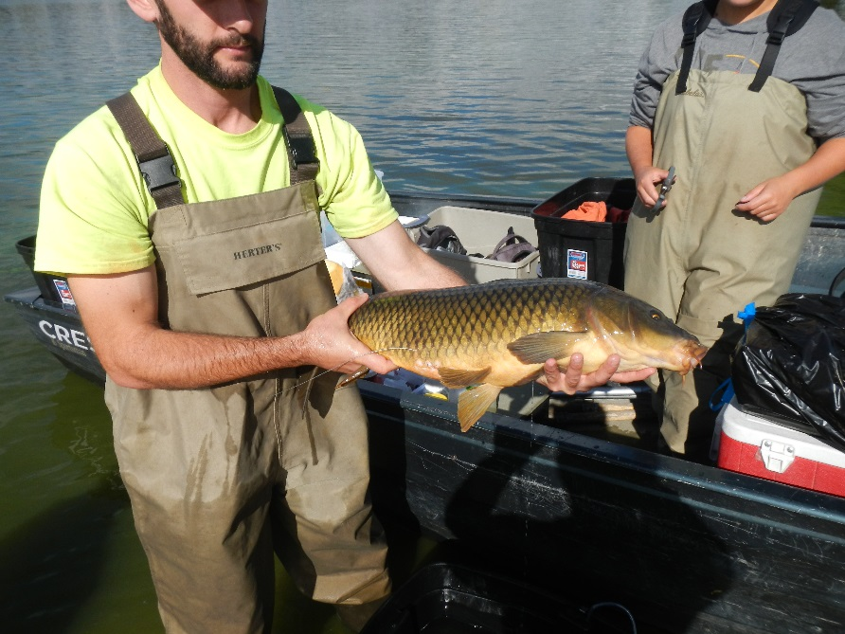
Additionally, the system appears to be a relatively open system with fish migrating between lakes, within lakes and also out of the lake chain. We currently have limited information about fish movement within and outside of the chain of lakes, however, the tracking of carp less than 24 hours post-surgery suggest strong movement of carp within the chain of lakes.
Figure 1. The radio tag is implanted in the carp and the antenna extends outside the body.

Table 1. Initial population assessment results.
Lake | Size (acre) | Size (hectare)  (ha) | 2016 Date | N | Shock Time (hour) | Total Length (cm) | Total Weight (kg) | Average Length (cm) | Average Weight (kg) | Estimated Density (carp/ha) | Biomass Mean (kg/ha)* | Estimated Population Size
Upper | 116.2 | 47.0 | 9/9 | 41 | 0.9 | 1,811.4 | 49.32 | 44.2 | 1.20 | 217.6 | 261.8 | 10,233
Middle | 56 | 22.7 | 9/9 | 24 | 0.7 | 1,046.7 | 27.84 | 43.6 | 1.16 | 164.5 | 190.8 | 3,729
Lower | 29.4 | 11.9 | 9/2 | 6 | 0.9 | 273.3 | 6.21 | 45.6 | 1.03 | 34.4 | 35.6 | 410
* 100 kg/ha is considered to be the maximum manageable density. Values greater than 100 kg/ha indicate an overabundance of carp.

Table 2. Second population assessment results.
Lake | Size (acre) | Size (hectare)  (ha) | 2016 Date | N | Shock Time (hour) | Total Length (cm) | Total Weight (kg) | Average Length (cm) | Average Weight (kg) | Estimated Density (carp/ha) | Biomass mean (kg/ha)* | Estimated Population Size
Upper | 116.2 | 47.0 | 9/29 | 48 | 0.8 | 2,114.1 | 61.76 | 44.0 | 1.29 | 285.6 | 367.5 | 13,432
Middle | 56 | 22.7 | 9/29 | 23 | 0.5 | 1,088.8 | 35.31 | 47.3 | 1.54 | 219.7 | 337.3 | 4,979
Lower | 29.4 | 11.9 | 9/29 | 5 | 0.5 | 247.6 | 9.55 | 49.5 | 1.91 | 50.1 | 95.7 | 597
* 100 kg/ha is considered to be the maximum manageable density. Values greater than 100 kg/ha indicate an overabundance of carp.

Table 3. Sex ratio of radio tagged carp in each lake.
Lake | N | Male | Female | Unknown | M/F Ratio
Upper | 19 | 10 | 7 | 2 | 1.43
Middle | 17 | 8 | 7 | 2 | 1.14
Lower | 4 | 3 | 1 | 0 | 3.00

Table 4. Fisheries information on radio-tagged carp.
Lake | Gender | N | Mean Mass (kg) | Max. Mass (kg) | Min. Mass (kg) | Mean Total Length (cm) | Max. Tot. Length (cm) | Min. Tot. Length (cm)
Lower | Female | 1 | 4.96 | 4.96 | 4.96 | 68.8 | 68.8 | 68.8
Lower | Male | 3 | 1.26 | 1.39 | 1.17 | 45.9 | 46.8 | 45.0
Middle | Female | 7 | 2.32 | 3.61 | 1.05 | 53.0 | 63.5 | 42.0
Middle | Male | 8 | 1.47 | 2.27 | 1.08 | 48.0 | 56.8 | 43.2
Middle | Unknown | 2 | 1.18 | 1.44 | 0.92 | 44.9 | 48.2 | 41.6
Upper | Female | 7 | 2.30 | 6.03 | 1.09 | 52.2 | 73.2 | 43.6
Upper | Male | 10 | 1.82 | 3.73 | 0.96 | 50.1 | 63.8 | 41.6
Upper | Unknown | 2 | 1.20 | 1.38 | 1.03 | 44.1 | 46.5 | 41.7

